How Would AI Have Changed Queen’s Creative Process?
Freddie Mercury records a melody; Brian May captures a guitar riff. In Queen's era, these fragments were archived and later reconstructed piece by piece during rehearsals.
They could do it, of course; they were Queen. But even they had to expend massive amounts of energy on the "internal friction" of integration, rather than facing a complete structural framework from the jump to judge, tweak, or even tear down and start over.
Today, an average band can record a song, upload it to MakeBestMusic, and receive a full arrangement framework in minutes. This means by the time they walk into the rehearsal space, they already have a foundation to discuss. This isn't a manifesto on AI "destroying" original music; it’s a look at exactly which "friction points" in a band’s creative life tools like MakeBestMusic target, and how a band can integrate them step by step.

The Most Infuriating Headaches in Band Creation
If you’re the "soul" of the band—much like Freddie was—these common bottlenecks will sound all too familiar:
- The "Fragment" Trap: It’s 1:00 AM, and you’ve written a riff you absolutely love. But at the next rehearsal, the bass doesn't lock in, the drummer can’t find the pocket, and the singer can’t find an entry point. After thirty minutes of struggling, you shelf it. The reality is: when you only have a fragment, it’s incredibly hard to build a complete framework out of thin air.
- The Rehearsal Time-Suck: You agree to meet at 7:30 PM, but everyone isn't actually there until 8:40. You spend forever tweaking gear and then waste even more time digging through old phone recordings to remember exactly how that jam went last week. Two hours later, you haven't even made it through the new song twice. Without a common point of reference, your precious rehearsal time is squandered just trying to reconstruct past ideas.
- The Demo Dilemma: You finally get the song tight and want to make a demo to submit to festivals. Then you see the quotes: professional studios start at hundreds of dollars. The recordings you make yourself with a basic interface sound thin and "dry," leaving you with zero confidence to send them out. Eventually, the song sits in your phone's camera roll—never released, never performed.
- The Stylistic Rut: You’ve got a few songs under your belt, but you can’t seem to break out of your usual patterns. You get a spark of inspiration from a random playlist—maybe a Reggae-style off-beat—but your guitarist says he only knows power chords. Your musical vision is miles ahead of your current technical execution.
With those challenges in mind, let's see how MakeBestMusic addresses them at every stage of the creative process.

A Guide to Creation: How MBM Solves Every Bottleneck from Inspiration to Finished Product
So, how do you solve these issues? Let’s look at how that same band’s workflow changes after adopting MakeBestMusic.

Step 1: From Recorded Fragment to Arrangement Framework
The next time a riff gets stuck, someone tries something different. They upload the recording to MBM, select Custom Mode in Create Music, toggle Instrumental, and upload that riff as a Reference. For the style description, they enter their usual vibe for text to song: Hard Rock, 70s style, guitar-driven.

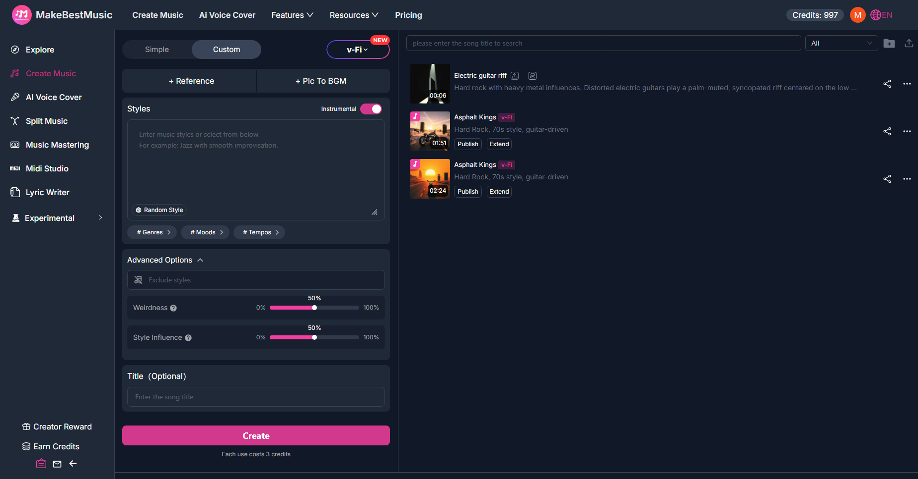
Minutes later, MakeBestMusic generates two versions. In one of them, the verse section features a bassline and drum interaction that the band never would have considered. It isn't writing the song for them—the riff is still theirs, and the chord progression is still theirs—but it provides a framework they hadn't imagined: the drum syncopation, the lock between the bass and kick drum, the placement of the rhythm guitar pads. It’s not a finished song; it’s a creative starting point to argue over, edit, and build upon. That "dead" riff finally starts moving forward.
Step 2: From Framework to Efficient Rehearsal
Previously, you’d walk into the rehearsal room and "brute force" the content. With MakeBestMusic, the process is reversed. You use Split Music to break the framework into stems—drums, bass, guitar. Each member exports their track and takes it home. The drummer listens and says, "I can change the fill in the bridge to something more 'me'"; the bassist finally masters the root note movement by listening to the isolated low end; the guitarist decides to swap a clean pad for a distorted layer.
By rehearsal day, everyone isn't "sight-reading" a phrase; they are polishing a structure they already know. During the session, the discussion shifts to dynamics, transitions, and where to leave "air," rather than "what's the next note?" In a single evening, the song’s skeleton is fully upright.

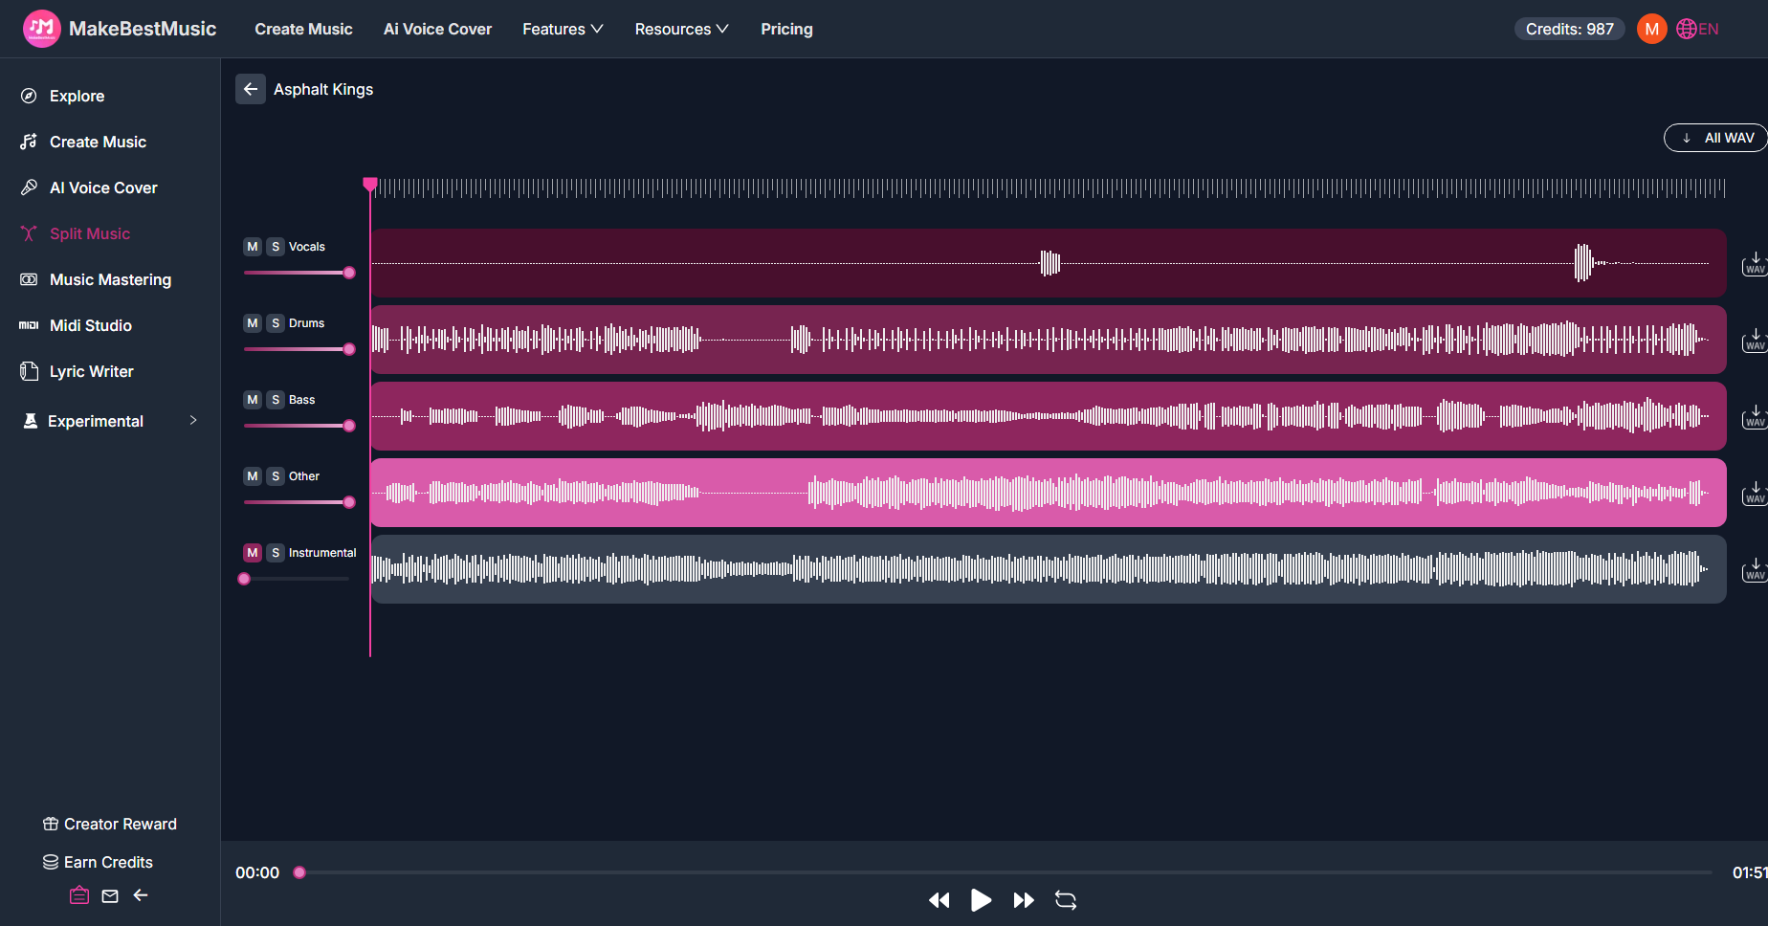
Step 3: Making the Demo Sound Like "Us"
The song is tight, but now comes the part everyone dreads: recording. This time, the band tries a different path. The lead singer uses the Persona feature to record a dry vocal take on a phone in the rehearsal room and uploads it to create a voice model.
Then, they return to Create Music, input the lyrics, set the style (specifying BPM and instrumentation effects), and select the singer’s own model for the vocals. The resulting demo features a backing track in their specific style, and the vocals sound exactly like the lead singer. Honestly, it might not have the high-end sheen of a multi-thousand-dollar commercial studio—the bass might need to be a bit tighter—but when they send it to a promoter, the question isn't "Is this AI?" but "When did you guys record this?"

Step 4: Expanding the Boundaries of Musical Styles
Once the first few steps are streamlined, creation becomes "light." It becomes about "playing" with music again. The band browses the MakeBestMusic homepage and finds a wealth of styles they’ve never tried.
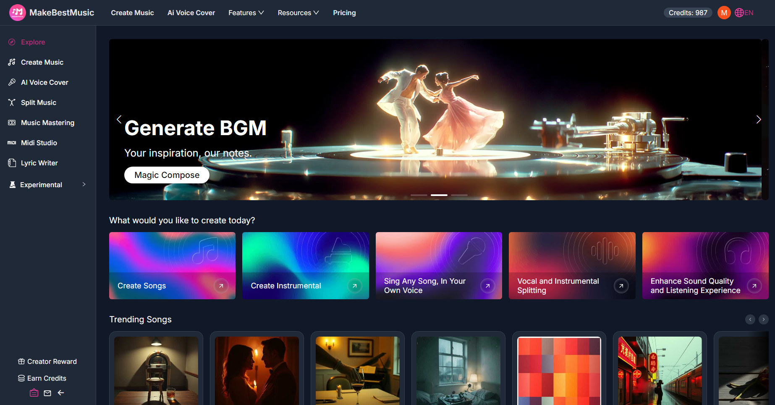
They take one of their typical hard rock tracks and put it through Style Transformation in the Reference section, typing in: "Reggae, off-beat guitar, relaxed groove." The AI returns a version where the guitar strumming pattern has shifted, and the drums have moved from a standard "four-on-the-floor" to a backbeat emphasis. The song's "breath" changes completely. It gives the guitarist a "lightbulb moment." He listens a few times and says, "Oh! So that's how an off-beat feels."
They might not know the deep music theory of Reggae, but MBM knocks over the first domino. It gives musicians the courage to try things they thought were "out of their league," providing inspiration that allows them not only to create surprising results but also to expand the boundaries of their own musical knowledge.

A Real-World Example: Fixing a Stuck Bridge in One Night
I recall a time when my band’s new song had a great verse and chorus, but we struggled with the bridge for ages. Every transition felt clunky. Going straight to the chorus felt rushed; adding an interlude felt tedious; changing the time signature felt disjointed. The musical tension we’d built up just kept evaporating.
Someone opened MakeBestMusic, uploaded the recorded chorus, and used Extend Music, setting the extension point at the beat right after the chorus ends. The prompt was: "Bridge, build-up section, drums intensifying, distorted guitar wash."
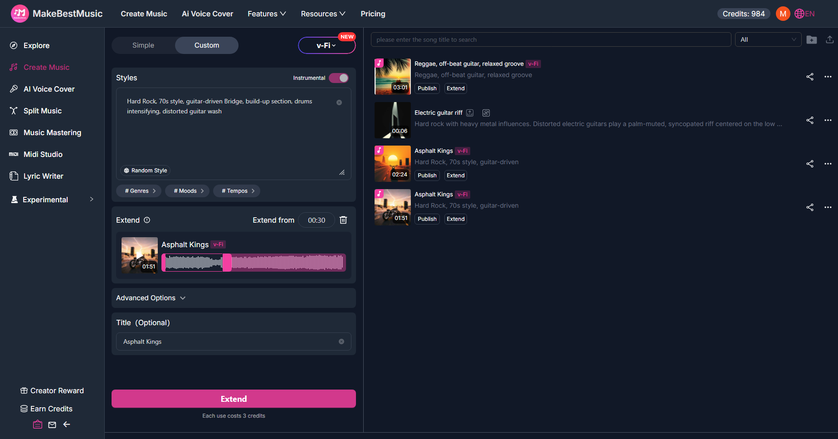
Minutes later, MakeBestMusic generated a few variations. While listening, we caught something unexpected: the drums started right after the chorus, with the snare density gradually increasing. The guitar layered a wall of distortion, and the low end pushed up slowly, creating a tension curve that matched exactly what we were looking for.
It wasn't a "finished" product yet. The drummer felt the snare wasn't "snappy" enough, so he pulled the drum stem using Split Music and tweaked it in a DAW. The guitarist added a live feedback squeal at the end of the bridge. The singer ran the full lyrics through MBM using his AI singing generator model to create a full demo with vocals. We went from being completely stuck to having a finished song we could actually listen to in less than a single evening. MakeBestMusic solved a problem that had plagued us for three days.
Conclusion
Let’s go back to the original question: If Queen had a helper this powerful, would Freddie Mercury have become a "greater" creator? Unlikely—Freddie was already a genius. But if they had a tool like MakeBestMusic, would they have faced less internal friction? Would they have explored more possibilities between the initial spark and the final master? Would they have produced even more masterpieces?
Almost certainly. They would likely have used to quickly validate bridge transitions, audition different instrumentation, and polish the arrangement framework before ever setting foot in an expensive studio. This would have saved their energy for the things AI can't do—the "soulful" stuff that only happens when four people clash and collaborate: the chemistry on stage, the emotional explosion during a vocal take. For the vast majority of grassroots bands, this is what matters most.
If you’re tired of seeing great ideas die as forgotten voice memos in a group chat, consider bringing MakeBestMusic into your rehearsal space. Use its suite of creative tools to see what new branches your music can grow.

